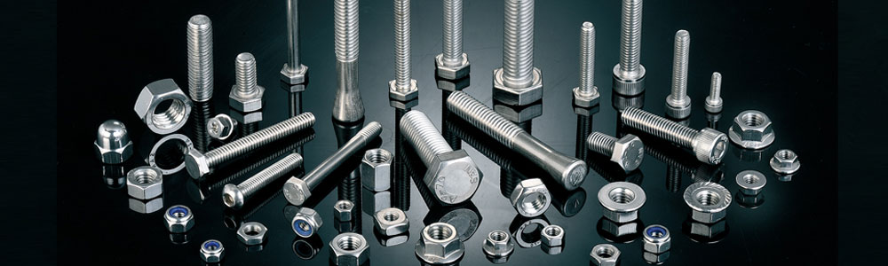

FASTENER:

Type : Stud Bolts (Hex, Eye, Square, (U J.) Nuts, (Nylock), Washer

(Star, Plain), Allen Caps, Screws, (CSK, Pen Head, Philip) etc.

Stainless Steel Fastener : ASTMA-193&194Gr.B8, B8M, B8C, 8, 8M, 8C etc. Duplex Steel 2205, 31803,

32750, 32760, 2101, 2304

High Tensile Fastener : ASTM A - 193 & A 194 Gr. B7, B7M, B16, L7, L43, 2H, 2HM

Cu-NI Fastener : C70400, C70600, (90 : 10), C71000, C71500 (70 : 30), C7 1640.

Nickel Fastener UNS N02200, N05500.

Monel Fastener : UNS N04400, N05500

Titanium Fastener : Gr. 1, 2, 3, DIN3, 7025, DIN3, 7035, DIN3, 7055

**HAA TABLE PIPE WALYA PAGE MADHE ADD KAR**

* 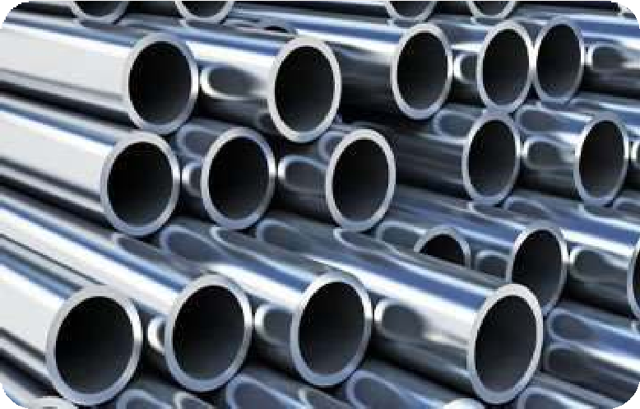**S.S PIPE DIMENSION**

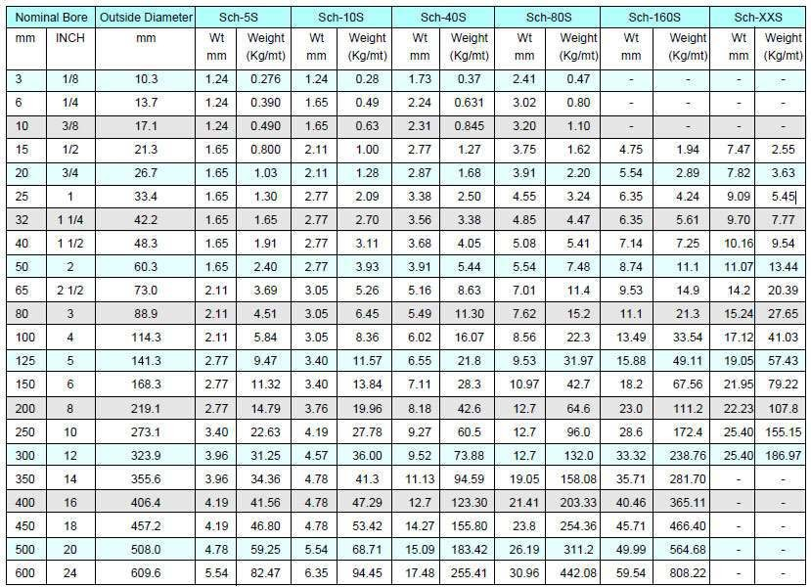

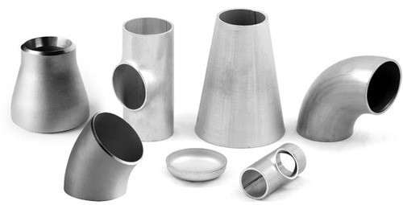**BUTT WELD WALYA PAGE MADHE HAA TABLE TAAKUYAT:**

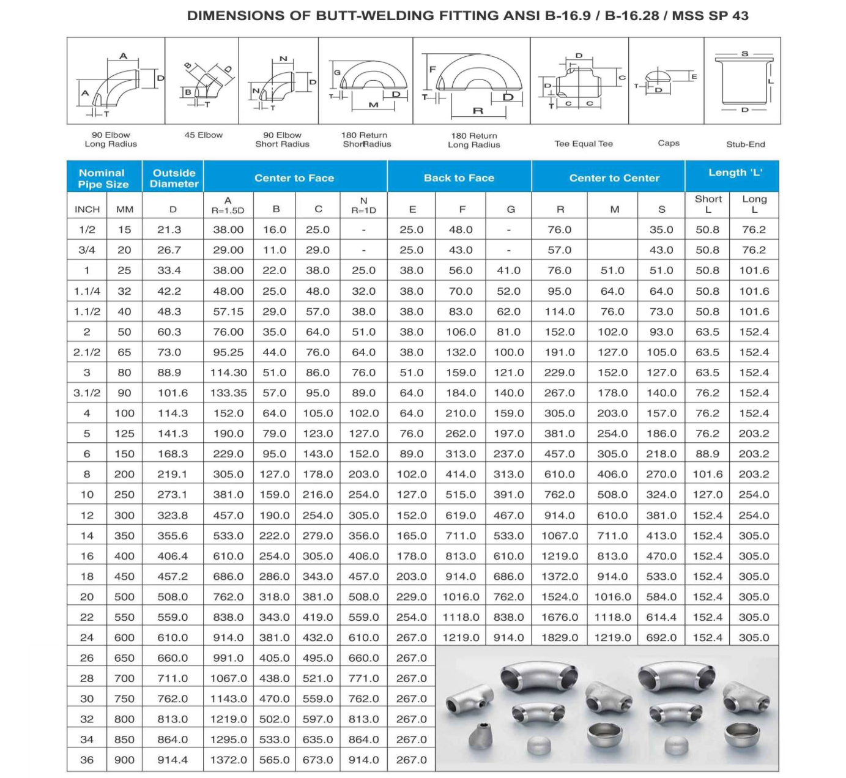

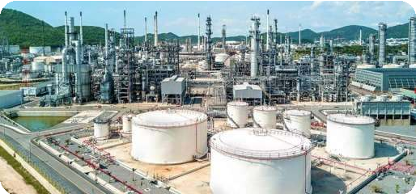// :HAA NEW SLIDE SHOW BUNAV://

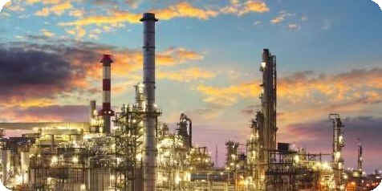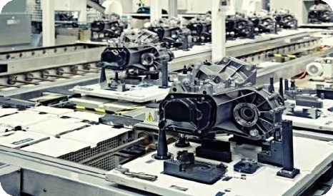

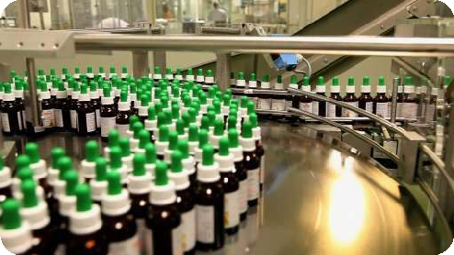



INDUSTRIES WE SERVE :

* + OIL &GAS INDUSTRIES
  + PHARMA CEUTICAL
  + PETRO — CHEMICAL
  + SUGAR INDUSTRY
  + HEAT EXCHANGE
  + PAPER & PULB
  + AUTOMOBILE
  + ENGINEERING
  + REFINERIES

//EK SPACE MADHE EXPORTS CHA BUNVU DETAILS HYAT AHEAT//

WE EXPORTS:

We Are Counted Among The Best Manufacturer, Exporter Stockist & Supplier. We Export 60% Of Our Range Of Flanges, Pipe Fittings And Forged Fittings To Many Countries Like Usa, Uk, Italy, Malaysia, Gulf Etc. We Would Appreciate To Get Your Esteemed Enquires And Look Forward To The Pleasure Receiving Your Valuable Response. We regularly Supply These Items To Many Leading Industrial Units Consisting Of *Ship Building, Petrochemical Plants, Steel Plants, Refineries, Chemicals, Fertilizers, Power Plant, Pharmaceutical, Ports, Oil &Gas, Railway, Mining, Cement Plants, Paper Mills, Sugar Mills, Fabrication Units Etc.*

Especially Stainless Steel Sheets/ Plates/ Coils/ Pipes To Engineering Industries Who Are Engage In The Manufacture And Fabrication Of Process Equipment. *We Can Supply The Items Even Under Third Party Inspection*

